Project Development Phase
Functional & Performance Testing
Date | 8 October 2026
Student Name | OviyaShree
Project Name | Metro Ticket Generating System in ServiceNow
Maximum Marks

Test Scenarios & Results
Test ID | Scenario | Expected Result | Status
TC-01 | Open booking form | Catalog item loads | Pass
TC-02 | Select source and destination | Stations selectable | Pass
TC-03 | Empty source/destination | Validation error shown | Pass
TC-04 | Default journey type | Single/return default populated | Pass
TC-05 | Fare calculation | Fare matches selection | Pass
TC-06 | Invalid travel date | Unapproved date rejected | Pass
TC-07 | Mandatory fields | Incomplete form blocked | Pass
TC-08 | QR code generation | QR code generated on ticket | Pass
TC-09 | Notification | Confirmation sent | Pass
TC-10 | End-to-end | Complete booking flow works | Pass
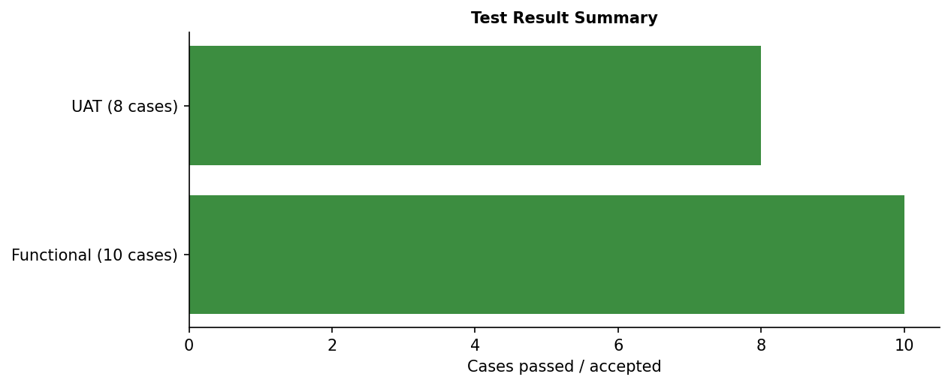
Figure 1: Functional test result representation.
Performance note: functional interactive testing was performed; formal concurrent-user load benchmarking was not supplied.

